TCP Congestion Control
Congestion is an important factor in packet switched network. It refers to the state of a network where the message traffic becomes so heavy that the network response time slows down leading to the failure of the packet. It leads to packet loss. Due to this, it is necessary to control the congestion in the network, however, it cannot be avoided.
TCP congestion control refers to the mechanism that prevents congestion from happening or removes it after congestion takes place. When congestion takes place in the network, TCP handles it by reducing the size of the sender’s window. The window size of the sender is determined by the following two factors:
- Receiver window size
- Congestion window size
Receiver Window Size
It shows how much data can a receiver receive in bytes without giving any acknowledgment.
Things to remember for receiver window size:
- The sender should not send data greater than that of the size of receiver window.
- If the data sent is greater than that of the size of the receiver’s window, then it causes retransmission of TCP due to the dropping of TCP segment.
- Hence sender should always send data that is less than or equal to the size of the receiver’s window.
- TCP header is used for sending the window size of the receiver to the sender.
Congestion Window
It is the state of TCP that limits the amount of data to be sent by the sender into the network even before receiving the acknowledgment.
Following are the things to remember for the congestion window:
- To calculate the size of the congestion window, different variants of TCP and methods are used.
- Only the sender knows the congestion window and its size and it is not sent over the link or network. The formula for determining the sender’s window size is:

Approaches for Congestion Control
Congestion in TCP is handled by using these three phases:
- Slow Start
- Congestion Avoidance
- Congestion Detection

Slow Start Phase
In the slow start phase, the sender sets congestion window size = maximum segment size (1 MSS) at the initial stage. The sender increases the size of the congestion window by 1 MSS after receiving the ACK (acknowledgment). The size of the congestion window increases exponentially in this phase. The formula for determining the size of the congestion window is Congestion window size = Congestion window size + Maximum segment size
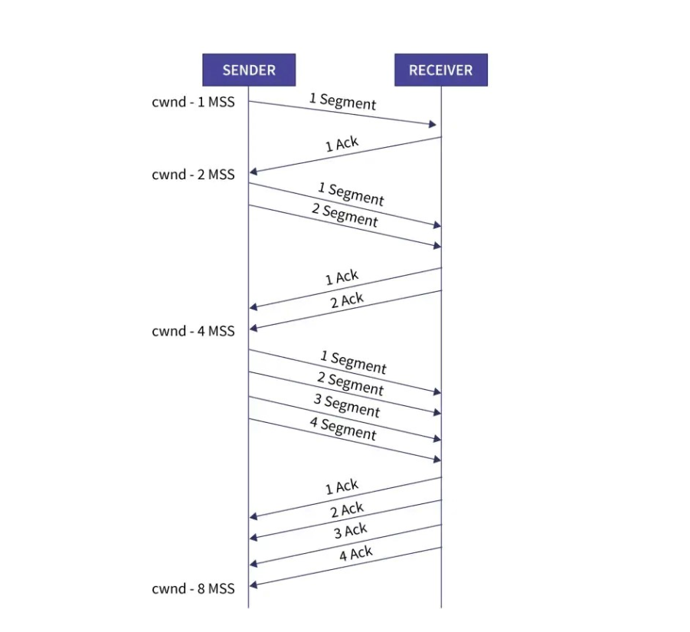
- Congestion Avoidance Phase
In this phase, after the threshold is reached, the size of the congestion window is increased by the sender linearly in order to avoid congestion. Each time an acknowledgment is received, the sender increments the size of the congestion window by 1.
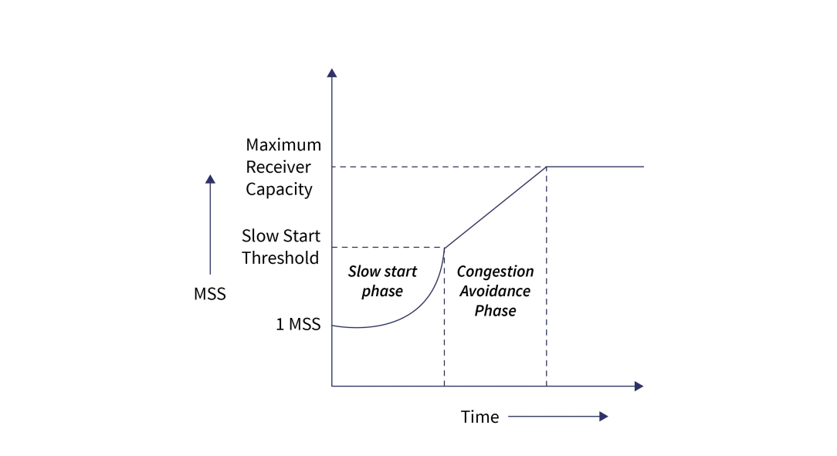
The formula for determining the size of the congestion window in this phase is Congestion window size = Congestion window size + 1
This phase continues until the size of the window becomes equal to that of the receiver window size.
- Congestion Detection Phase
In this phase, the sender identifies the segment loss and gives acknowledgment depending on the type of loss detected.
Case-01: Detection On Time Out
- In this, the timer time-out expires even before receiving acknowledgment for a segment.
- It suggests a stronger possibility of congestion in a network
- In this, there are chances that a segment has been dropped in the network
Reaction in response to Detection on time out:
- Setting the threshold to start at half of the current size of the window
- Decreasing the size of the congestion window to MSS
- Slow start phase is resumed
Case-02: Detection Of Receiving 3 Duplicate Acknowledgements
This case suggests the weaker possibility of congestion in the network. In this, the sender receives three duplicate acknowledgments for a network segment. The chances are that fewer segments have dropped while the one sent later might have reached.
Reaction on receiving 3 duplicate acknowledgments:
- Setting the threshold to start at half of the current size of the window
- Decreasing the size of the congestion window to that of the slow start threshold
- The congestion avoidance phase is resumed

